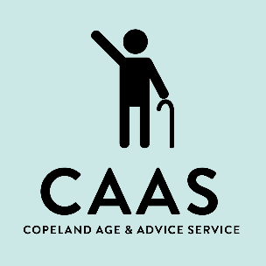
Copeland Age and Advice Service (CAAS)
A20 Haig Enterprise Park
Kells
Whitehaven
CA28 9AN
Tel: 01946 552166
Email: referrals@caasteam.com

Confidentiality Statement

This statement must be read and signed by all CAAS staff and volunteers at the start of their employment.

The signatory should keep a copy, and one copy should be held by the manager. During your duties, you may access confidential information that should not be disclosed unless required for your job or with specific permission from CAAS. This includes client and staff records, especially information on computers and printouts; ensure client information is secured and kept confidential according to requirements.

Do not remove or copy any employer documents or items containing confidential information without authorisation. Return all such items upon request or when your employment ends. Breach of confidentiality may lead to disciplinary action, dismissal, and civil or criminal charges.

Unauthorised disclosure of information may lead to legal consequences for both you and CAAS. Do not disclose or use confidential information about CAAS’ business, clients, or employees without senior management's express authorisation.

I confirm my legal duty of confidentiality to all CAAS clients, past, present, and prospective. I will not disclose unauthorised information about clients, staff, or CAAS’ affairs. I understand that breaching this duty may result in disciplinary action or legal proceedings.

Important Points:
- Only those with a need to know can access client details. Accessing information without justification is illegal.
- Keep PC screens out of sight when displaying personal information.
- Do not leave confidential information unattended; shred or dispose of it in ‘confidential waste’.
- Avoid sending confidential information via email.
- Log out after using your PC or terminal and never share passwords.

Staff/Volunteer Name (print):

…………………………………………………………………………
Signed:

…………………………………………………………………………
Date:

…………………………………………………………………………

